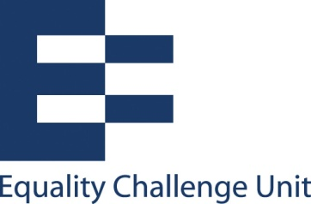

Unconscious bias training: Hand-out 1

What is unconscious bias?
Unconscious bias refers to a bias of which we are not in conscious control.
It is a bias that happens automatically and is triggered by our brain making quick judgments and assessments of people and situations, influenced by our:
- Background
- Cultural environment
- Personal experiences
(ECU: 2013 Unconscious bias in higher education)

Impact on behaviour and decisions
Unconscious biases can impact on our instinctive reactions, or the split second assumptions and decisions we make.
However, whilst our unconscious thoughts often happen instantly and quicker than our conscious thoughts, they can still prevail even after our conscious thoughts have had a chance to catch up. The way we perceive people can continue to be based on those assumptions and stereotypes which we unconsciously associate with them.
In a work situation, our unconscious biases can have a significant influence in a variety of situations, for example:

Staff
- Who we listen to most intently
- Who we disregard most easily
- How good we think someone is at their job and/or how good we think someone would be at a job for which they are applying
- How encouraging or discouraging our body language is towards different people

Students
- How suitable we think a student is for a particular course
- How well we think a student will perform on a course
- How much effort we perceive a student to be making
- The reasons we assign to students who are performing particularly well and/or who appear to be struggling

Psychological studies
There are numerous examples of psychological studies based on the impact of bias on behaviour and decisions and this is just one example.
Moss-Racusin et al (2012) had staff in science faculties rate the application of a student for a position as a laboratory manager. The application was used 127 times and randomly assigned either a female (64 times) or male (63 times) name. Selectors rated the male applicant as significantly more hireable than the female applicant. They also chose a higher starting salary and offered more career mentoring to the male applicant.
The gender of the selector did not affect responses.

For an introduction to unconscious bias, please watch the following short video from enei, the Employers Network for Equality and Inclusion: https://www.youtube.com/watch?v=rbe5D3Yh43o

Moss-Racusin, CA, Dovidio, JF, Brescoll, VL, Graham, M & Handnelsman, J (2012) ‘Science faculty’s subtle gender biases- favour male studens’. Proceedings of the National Academy of Sciences for the United Sates of America 109(41): 16474-16479

