Audit of Patients with Hyperkalaemia undergoing Nephrostomy

Introduction
Percutaneous nephrostomy (PCN) under local anaesthesia or retrograde ureteric stenting under general anaesthesia are effective treatments to relieve renal impairment due to ureteric obstruction. Pre-procedural hyperkalaemia is often a cause of concern for anaesthetic and radiological staff due to the associated risk of dysrhythmia and sudden death. Decompression of the ureteric obstruction, either by PCN or retrograde ureteric stent, usually improves renal function and corrects hyperkalaemia with a low morbidity. Retrograde ureteric stent insertion in patients with malignant ureteric obstruction carries a higher failure rate compared to PCN, furthermore the majority of patients will need a general anesthetic which may be challenging when complicated with hyperkalaemia.

Material & Methods:
We audited the outcomes of patients who underwent nephrostomy for hyperkalaemia with renal failure secondary to ureteric obstruction over a 5 year period. An experienced radiologist or registrar under supervision performed all procedures.

Results
During our study period, a total of 61 patients (40 males and 21 female) with mean age of 69.7 years (range 35 to 94 years) underwent 69 procedures. All patients had hyperkalaemia and hydronephrosis due to ureteric obstruction. Pre-nephrostomy hydronephrosis was unilateral in 37 cases, bilateral in 27 cases, with one transplant kidney. In four patients the biochemistry failed to improve after unilateral nephrostomy and a subsequent contralateral nephrostomy was necessary.
The underlying cause was malignant ureteric obstruction in 46 patients, obstruction from ureteric calculi in 8 patients, pyonephrosis in 4 patients and obstruction from a combination of retroperitoneal fibrosis and/or inflammatory aortic aneurysm in the remaining three patients.
All patients received prophylactic antibiotic prior to the procedure. Twenty-nine (42%) had medical treatment of hyperkalaemia prior to nephrostomy. This was either to prevent further increase in serum potassium whilst waiting for a nephrostomy, or intervention in a hyperkalaemic state was considered hazardous and drainage was delayed to allow correction. Of these 29 cases, the mean potassium level was reduced from 6.7 (range 5.4 – 9.3) before medical treatment to 5.8mmol/L (4.0 – 7.4mmol/L) with a mean reduction of 0.9 mmol/L (range: + 0.8 to – 4.2 mmol/L). A combination of medical measures was used for most patients, with insulin dextrose being the commonest (n= 20), oral calcium resonium (n=17) and haemodialysis (n=8) in others. Mean delay from presentation to nephrostomy was 1.9 days.
Forty (58%) had nephrostomy without prior medical treatment of the hyperkalaemia. The mean serum potassium in these patients was 5.6 (range 5.1 – 7.5 mmol/L). Twenty-four of these procedures (60%) were done within 24 hours of presentation. The mean time delay from presentation to nephrostomy was 1.4 days (range: 0-3 days).
Five patients (7%) had complications from PCN: Two patients had transient pyrexia which settled with antibiotics. Three patients with evidence of sepsis had atrial fibrillation (AF), two reverted to sinus rhythm spontaneously and the third needed temporary treatment with verapamil. There were no hyperkalaemia or procedure related complications.
Bilateral PCN was done in 27 cases, resulting in normalisation of the serum biochemistry in 22 (81%) cases. In the remaining 5 cases there was no improvement in the serum potassium or creatinine.
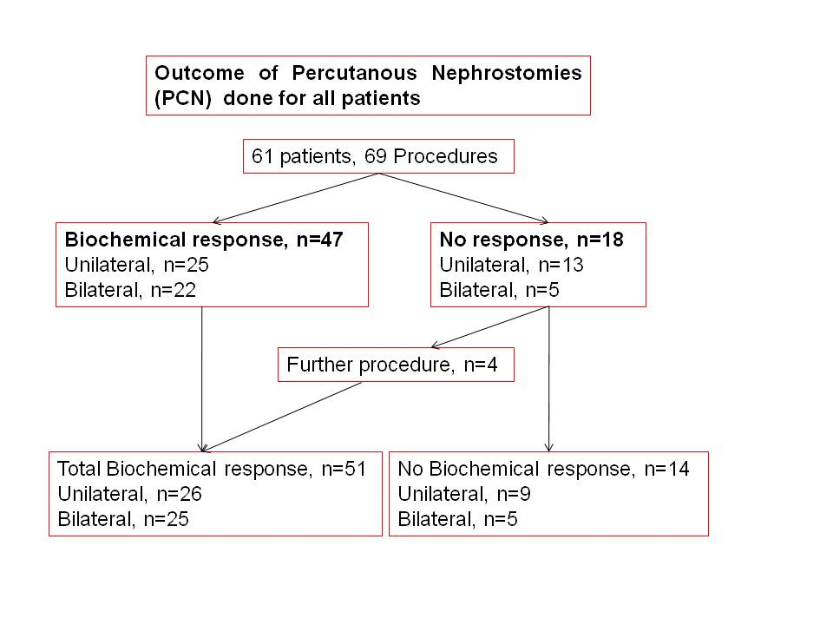
Unilateral nephrostomy was performed initially in 37 cases, and one transplant kidney. In 25 (66%) cases there was normalisation of the serum potassium and creatinine, but with no significant improvement in 13 cases. Of the latter, 2 cases needed the contralateral side drained and two other cases needed a repeat procedure due to nephrostomy catheter extrusion.

Discussion
In our study, initial percutaneous nephrostomy was performed within 24 hours of presentation in 42 (62%) of patients and was successful in normalising serum potassium and creatinine in 50 (72%) and 25 (36%) of the patients within 48 hours. The minor complication rate was 7%, with atrial fibrillation, pyrexia and confusion more likely in patients with stone disease and leucocytosis, but was not associated with severity of hyperkalaemia. The complications in our study were well within acceptable levels as published by the American College of Radiologists (4% haemorrhage and 10% septicaemia /septic shock).

