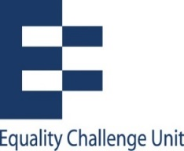
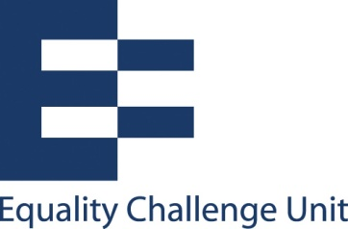

Unconscious bias training: Hand-out 8

Micro-behaviours
- Unconscious bias operates at a very subtle level, below our awareness. It results in almost unnoticeable behaviours (micro-behaviours), such as paying a little less attention to what the other person says, addressing them less warmly or talking less to them.
- We tend to be less empathetic towards people who are not like us. These behaviours are small and may not be picked up as discriminatory or even consciously by the person on the receiving end - but their long-term effect can be corrosive of confidence and self-esteem and may lead to defensive or even aggressive behaviour.
- Unconscious beliefs and attitudes have been found to be associated with language and certain behaviours, such as eye contact, blinking rates and smiles.
- Studies have found, for example, that school teachers clearly telegraph prejudices, so much so that some researchers believe white children and ethnic minority children in the same classroom can effectively receive different educations.
- One experiment showed that white interviewers sat farther away from black applicants than from white applicants, made more speech errors and ended the interviews 25 per cent sooner.

About the impact of micro-behaviours

- A person who carries the stigma of group membership can anticipate its debilitating effects.
- Studies show that black teenagers are aware they are stigmatised as being intellectually inferior and that they go to school bearing what one psychologist described as a "burden of suspicion," affecting their attitudes and achievement.
- Similarly, studies found that when female students are reminded that women are considered less good than men at maths, their performance worsens.
- And in science, technology and engineering contexts, the unconscious bias about performance can affect women interviewers and examiners as well as men.

For ideas about how to provide positive signals to everyone that you interact with professionally, see: https://www.skillboostersvideo.com/downloads/top-5-positive-micro-behaviours/

