Trainee Admin Handbook
This guide has been written for all Deanery Training Management Admin teams (in Scotland), to support them in their use of SOAR.
If we’ve missed anything, please let us know.
William Liu
Training Manager (Medical Appraisal)
Version 0.2
21/07/2021

  - Content:
Background 2
Overview of Trainee processes on SOAR 2
Trainee Data on SOAR 3
Which Trainees are NOT on SOAR? 3
New Trainees on SOAR 3
What TR Admins do on SOAR 4
Deal with Trainee Login Requests 4
Amending data on TurasTPM 5
Updating TPD information on SOAR 5
Updating other TR Admins on SOAR 7
Initiate Trainees’ Self Declarations 7
Unlock Declarations 9
Delete Declarations 9
Examples of complex situations 10
Contacting the Helpdesk 11

Background
It was agreed at Scottish Government level that SOAR would be used as the common pathway tool for all doctors working in Scotland for Medical Revalidation.
Trainee doctors in Scotland are asked to use SOAR to complete their Health, Probity, Complaints, and Work History declarations as part of their annual ARCP review meetings. These self-declarations, along with ARCP outcomes and other information available to the RO, will help form the basis of the Trainee’s Revalidation recommendation.

Overview of Trainee processes on SOAR
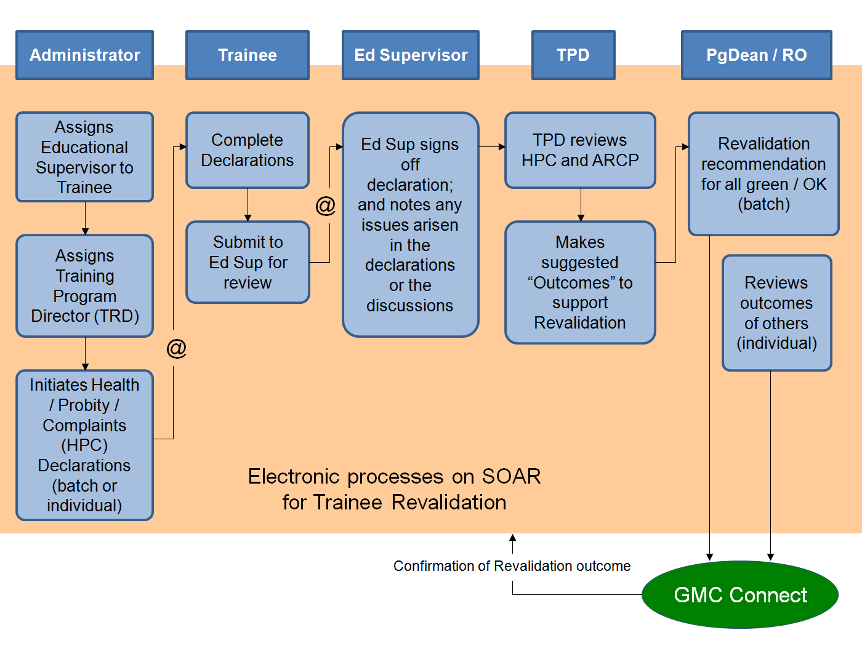
There are five key user roles for Trainee Revalidation on SOAR:
- Deanery Admin Teams (you)
- Trainees (who complete the annual self-declarations)
- Trainee’s Educational Supervisor (who reviews and signs off their Trainees’ declarations)
- Training Programme Directors (TPDs - who review the ARCP and declaration details to make a suggested outcome to support the Trainees’ Revalidation)
- Post-Grad Dean / Responsible Officer (makes Revalidation recommendations to the GMC)
Full PowerPoint available for download at: https://www.appraisal.nes.scot.nhs.uk/help-me-with/soar/trainees.aspx

Trainee Data on SOAR
All Trainee/Trainer data on SOAR is imported from TurasTPM via overnight automated import processes. Around midnight, TurasTPM runs a scheduled script that generates two data files which are sent to a secure folder on SOAR. Around 1am, SOAR will import the two files (one is Trainee data, the other ARCP data). This takes several hours to process due to the volume of users involved.
A Trainee’s Ed Sup will be linked automatically on SOAR from the import information provided – but not TPDs, they will need to be manually added to SOAR.
To ensure that Trainee data comes from one central source (TurasTPM) and to avoid data duplication, it is not possible to amend Trainee details on SOAR.
Incorrect data is to be amended on TurasTPM first, which will get re-imported into SOAR later in the next overnight processes.

Which Trainees are NOT on SOAR?
The following Trainee groups are not required to complete self-declarations on SOAR, and as such they are not included in the nightly data import:
- Dental Trainees
- FY1
- Doctors in LAS Posts*
- Doctors in LAT Posts for less than 3 months*

LAS (Locum Appointment for Service)
Those doctors who are in LAS posts are out of programme and as such, they should adhere to the processes (such as annual appraisals) of the locum agency they are employed by or NHSScotland health board they work in.

LAT (Locum Appointment for Training)
Those trainees who are in LAT posts for more than 3 months will require to complete the trainee self-declarations.
Those who are in LAT posts for less than 3 months are treated in the same way as those in LAS posts, and they are not required to complete the trainee declarations.

New Trainees on SOAR
When a new Trainee is added to SOAR via the import, SOAR will automatically set up a user account and email the Trainee with an introduction and their login details.

What TR Admins do on SOAR
There are several key tasks required of the TR Admin role on SOAR:
- Dealing with Trainee Login Requests
- Amending data on TurasTPM
- Initiating Trainee self-declarations
- Update TPD information
- Update fellow Admins information (leavers/starters)

Deal with Trainee Login Requests

(1) Check that the trainee is on TurasTPM and SOAR
All trainees should have received automated login details when first added to SOAR. If for whatever reason they say they don’t have the login details – check to make sure they are on TurasTPM first. If they are not on Turas, please refer to the deanery regional procedure and await user's addition. (Trainee doctors are added to Turas from UK national systems after a number of checks are performed.)
If they are on TurasTPM, they should also be on SOAR (unless they are in the excluded groups like FY1, Dental, LAT/LAS etc).
Look up the Trainee by clicking on “TR Trainee” from the menu on the left and enter details of trainee in the search filters such as surname (check spelling), GMC number of email address.
If you are unable to locate the trainee on SOAR (and they are definitely on TurasTPM) please contact the helpdesk for assistance.
Otherwise, click on their name from th search results to go into their profile.

(2) Unlock account or Assign dummy password
When you are in the trainee’s profile page, by default the first page you will see if their imported TurasTPM details (address, programme, EdSup, TPD etc). Click on the “SOAR details” tab along the top to get to the login details page.
- If the account is locked (a):
  - Select “unlocked” (b)
  - Click “Save” (c)
  - Click on “Reset password and security questions” at bottom of page (d)
- If not locked and trainee has simply forgotten their password, a new dummy password need to be assigned:
  - Enter a new password (e) make sure it’s at least 8 characters long, alpha-numeric, upper and lowercase and include a symbol (e.g. Pizza£567, Yellow!568 etc)
  - Type in same password to confirm (f)
  - Click “Save” (c)
DO NOT fill in the Security Questions section – that’s for the user to complete themselves!
When account is reset or password is changed, the system will trigger an email to the user confirming the new details; and they will also be asked to change it on logging in.
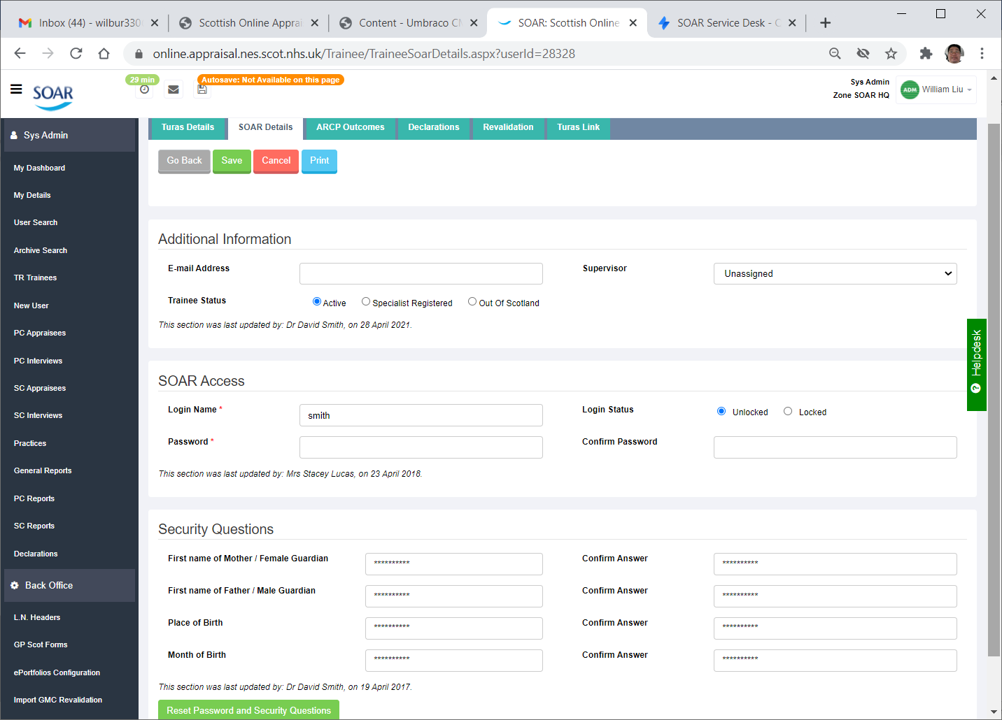
e
f
d
c
b
a

Amending data on TurasTPM
The SOAR helpdesk will often receive queries from Trainees, informing us of change in Supervisor, or home address, or contact details. As we have no editing permission trainee details on SOAR or TurasTPM, we will ask them to contact the relevant Training Management specialty team so they can update TurasTPM: https://www.scotlanddeanery.nhs.scot/about-us/our-people/training-management-team/
All supervisors (as well as TPDs) should already be SOAR users, as all doctors are required to use it for their own appraisal purposes. Linkage between Supervisor and Trainees for declarations is made via the automated import from TurasTPM. If data is incorrect/out-of-date, TurasTPM needs updated and SOAR is subsequently updated via overnight processes the next day.
By and large, these are the most straightforward queries to deal with. Unless the trainees are in the middle of completing their declarations… but before that, let’s go through how to actually create the declarations.

Updating TPD information on SOAR
Like the Ed Sups, TPDs should already be a SOAR user and will have an appraisal account. Unlike the Ed Sup/trainee linkage though, TPD information is NOT imported to SOAR. Therefore, should TPDs leave their post and a new TPD comes in, this needs to be updated manually on SOAR.
Let’s start by adding TPDs to SOAR. To do this:
- Make sure you have the TPD’s correct GMC number by checking on the GMC register: https://www.gmc-uk.org/registration-and-licensing/the-medical-register#searchTheRegister (unlike Turas, SOAR uses the GMC number as a unique identifier)
- Login to SOAR and click on “User Search” from the menu
- Use the GMC number field to search for the TPD in question
- Click on the user’s name from the results (they may have multiple roles on SOAR, e.g. appraisee, appraiser, Ed Sup etc – but all belonging to the same GMC reference)
- When in the user’s profile, click on the “Roles” tab along the top (a)
- Scroll to the bottom of the page and in the section “Add new role in Trainee segment” select “TR Training Programme Director” from the dropdown and click “Add”
- Back at the top of the page you should see a new “Training Programme Director” tab - click on this (b)
- In the dropdown (c), select the appropriate programme the user is TPD for and then click “Add” (d)
- If use is TPD for more than one programme, repeat the above step to add more programmes
- When all programmes are added, click on the Save button to finish (e)
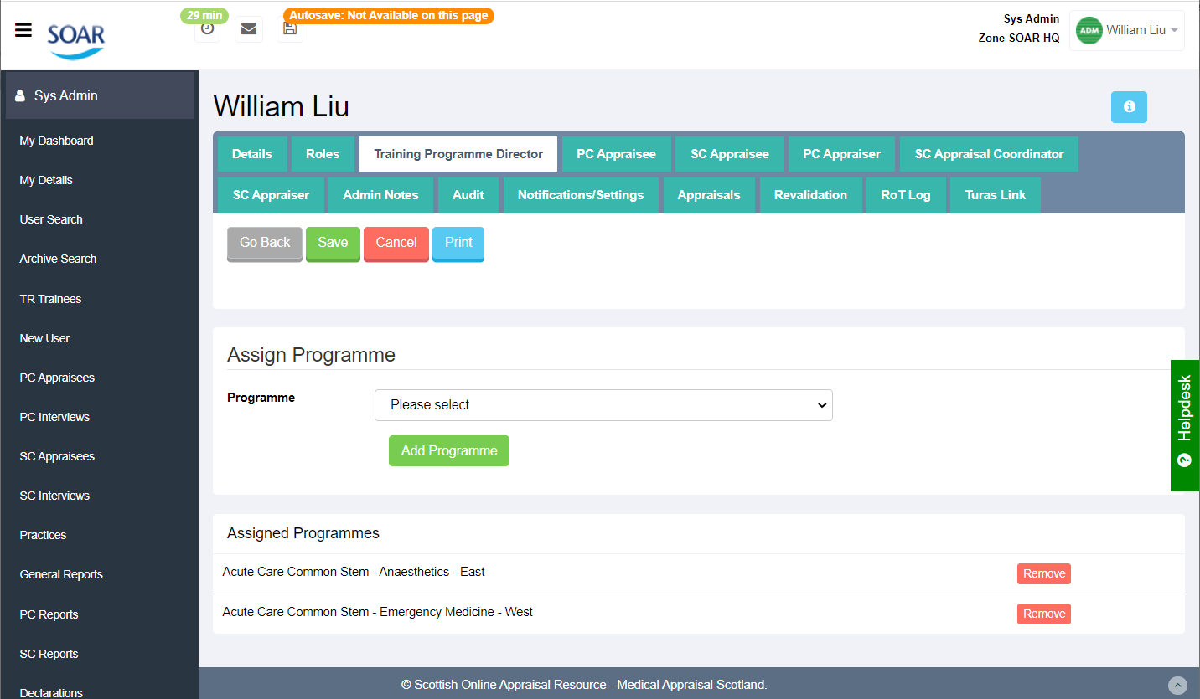
c
d
e
b
a
For data protection, make sure you remove the old TPD’s access on SOAR as well.
To do this, follow steps 1-5 above, taking you to the user’s “Roles” tab, where you will see a list of all of that user’s assigned roles on SOAR. From the list of user roles, locate the role “TR Training Programme Director” from the list and click on the corresponding “Remove” button – that’s it.
This is actioned by the training management team as the SOAR team has no access or knowledge to verify who the TPDs are.

Updating other TR Admins on SOAR
To add or remove a fellow admin (e.g. Starters and Leavers), it’s similar protocols in principle to adding and removing TPDs. Only difference is, when it comes to adding a new admin, a new user account needs to be created. To do this:
- Login to SOAR and click on “New User” from the menu
- Add First name and Last name, email address, a dummy GMC reference (prefix using initials followed by numbers e.g. WL100 etc) and a login name but leave the password fields blank
- Click Save when done
- This creates the initial profile and you should see the “Roles” tab appear on the top, click on this
- Scroll to the bottom of the page and in the section “Add new role in Trainee segment” select “TR Admin” from the dropdown and click “Add”
- Scroll back to the top of the page and click on the “Details” tab
- In the password boxes enter a dummy password (same rules as before for trainees - at least 8 characters long, alpha-numeric, upper and lowercase and include a symbol) finish by clicking on Save.
Steps 1-3 above creates the user profile on SOAR;
Steps 4-5 adds the actual user role; and
Steps 6-7 adds the password which triggers the auto email to the new admin (steps 1-3 doesn’t trigger any emails, hence why you leave the password last)
That’s how to add a new TR Admin on SOAR; but same as the TPDs, you need to make sure to remove a leaver’s access to SOAR after they have left as part of data policies.
To do this:
- Look up the TR Admin’s profile via the “User Search” function on SOAR
- When in their profile, click on the “Roles” tab
- In the list of Login Roles, locate the line which lists “TR Admin” and click on its corresponding “Remove” button on the right.
That’s the standard user management tasks required of TR Admins on SOAR.
The main task though is to initiate the annual self-declarations for trainees to complete.

Initiate Trainees’ Self Declarations
Creating individual declarations for Trainees is relatively straightforward:
- Login to SOAR and click on “Initiate Declarations” from the menu
- Search for the Trainee via GMC number (or other filters)
- From the results listed, tick the box next to their name and click “Initiate” button at bottom of page
That’s it. But what about creating new declarations for all trainees?
When we first introduced the self-declarations (in 2013), all “current” trainees were imported across from Pinnacle to SOAR, and all of them had a declaration created for them as part of the original import process. This function has been disabled and all declarations need to be created manually.
The steps required are:
- Login to SOAR click on “Initiate Declarations” from the menu (a)
- Use the search filters to search for your particular programme’s trainees (b)
- From the filtered results, tick the box on the trainees you wish to create declarations for (c)
- Scroll to the bottom and click the “Initiate” button (d)
The page may take several seconds to load (especially if you have a large list) but DO NOT double-click or refresh the page – it just takes one click, otherwise you WILL create duplicate declarations which will need to be manually deleted.
If you wish to be doubly sure on who you need to create declarations for, follow steps 1 and 2 above, but when you have the filtered results, scroll to the bottom of the page and click on “Export all search results” (e)which will create a spreadsheet and downloaded to your computer.
Using the “Export selected Trainees” button (f) will generate a spreadsheet of those who have been ticked/selected on the list.
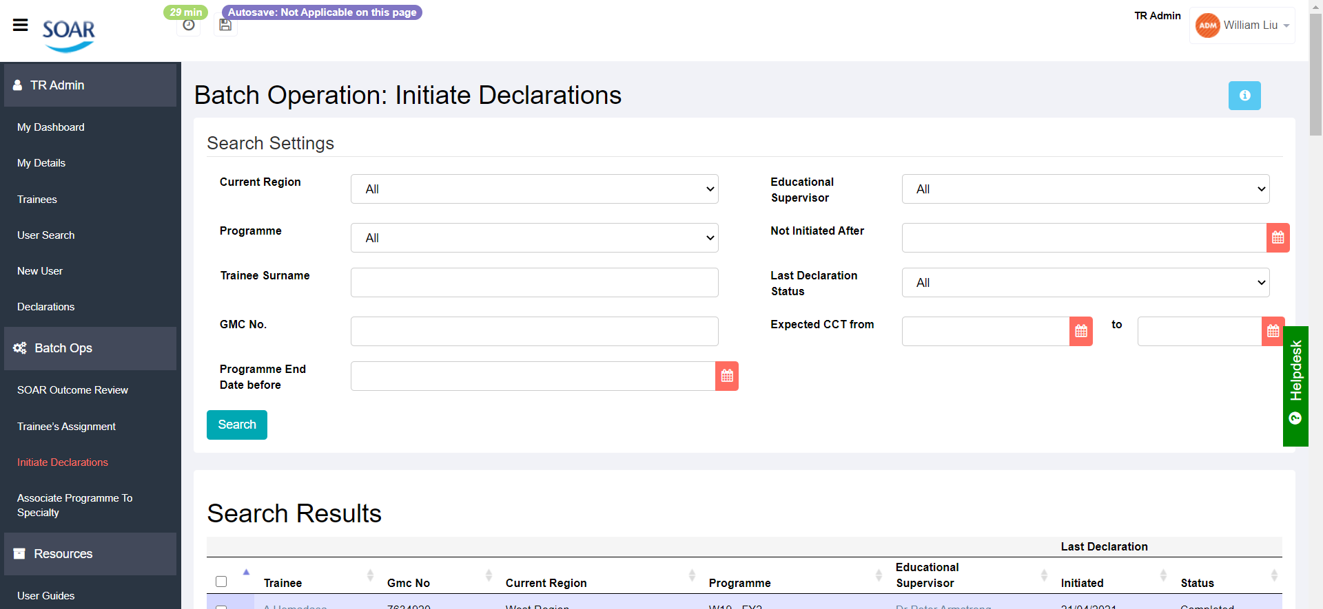
f
e
b
c
d
a

Can’t initiate / tickbox greyed out
If the tickbox against the trainee’s name is greyed out and you can’t select it, it is because that trainee has no Ed Sup assigned on SOAR. Double check the Ed Sup pairing on TurasTPM and double check the Ed Sup’s “Date Range” with the trainee; if it’s in range, check the Ed Sup’s GMC number – if it doesn’t match what’s on SOAR then the EdSup/Trainee link wouldn’t import.
If you have trainees who are not appearing on the list but should be, check TurasTPM.
To escalate, contact the SOAR helpdesk (SOAR@nes.scot.nhs.uk) with details of the Ed Sup and Trainee (names, GMC numbers, emails etc) and we will try to investigate this further.

Unlock Declarations
We’ve covered how to deal with user login requests, and how to create declarations – two of the more critical tasks required of you on SOAR. One other not uncommon request is for Trainees to add more to their work history or edit their submitted declarations. However, once a self-declaration has been submitted, Trainees cannot make changes – the only way to facilitate this request is to unlock the declarations first – which TR Admins can do.
To unlock a Trainee’s declarations:
- Login to SOAR
- Click on “Declarations” from the menu
- Enter the search settings (GMC, Surname, etc) and click Search
- From the listed results, check against the Declarations Date column and click on the corresponding View icon to go into that set of declarations
- When in the declarations page, scroll to the bottom and click on “Reject declarations”
- You will be prompted to provide a reason for the unlock. Enter a message like “as requested by Dr X and Dr Y” and click the “Reject” button – and that’s it.
This changes the status of the declarations from “Awaiting Sign off” to “Not Submitted”; and SOAR will email the Trainee and the Ed Sup, informing them the declarations have been unlocked, along with the message you entered in the previous prompt.

Delete Declarations
As TR Admin, you also have the function to delete any declarations as required. This could be due to accidental double-clicks at the initiating stage, or it could be the Trainee is not currently in a training programme (e.g. Clinical Development Fellows).
To do this follow steps 1-3 above to get a list of declarations for the trainee in question, then from the listed results, click on the corresponding red “Delete” button on the right, that’s it.
If the Delete button is greyed out, then the interview will have been either submitted or signed off. Only declarations in the “Not submitted” status can be deleted; therefore, to delete any submitted (or even completed) declarations, you will need to unlock them first (steps 1-6 above), then delete.
If you are unsure or uncomfortable with this, please contact the SOAR helpdesk for further assistance.

Examples of complex situations
Scenario: | Incorrect Ed Sup on Trainee declarations
Description: | Trainee completed and submitted declarations, but it has the incorrect Ed Sup listed.
Solution: | First of all – update the correct information on TurasTPM (otherwise any change made via below steps on SOAR will be overwritten unless Trainee and new Ed Sup managed to sign off declarations before midnight).  If declaration has not been signed off:  Very straightforward – navigate to declarations, and on the “Details” tab where it list who initiated the declarations, who the trainee and Ed Sup are – you should see a “Change” button next to the Ed Sup’s name. Click on it, select the new Ed Sup from the dropdown, and click Save.  If declaration has been signed off:  Check with Ed Sup and Trainee (who probably aren’t aware that the declaration has been signed off) to see if they still want to make the change. If yes, unlock the declarations and repeat above steps.

Scenario: | Unable to get Ed Sup to sign off on Trainee declarations
Description: | We’ve had situations where the Ed Sup could not be contacted and they’ve not reviewed or signed off the Trainee’s declarations.
Solution: | Contact either the Trainee’s TPD or Post-Grad Dean – both have the function to review and sign off the Trainee’s declarations directly in place of the Ed Sup (without the need to change the Ed Sup assignment).

Scenario: | Educational Supervisor not on SOAR
Description: | Sometimes, the Ed Sup might not appear on SOAR after the overnight imports…
Solution: | This could be for one of two reasons: either TurasTPM or SOAR has the wrong GMC number for the Ed Sup; or the Ed Sup is not a SOAR user.  If there is a mismatch of GMC number, please check the GMC register first. If Turas has the wrong GMC number, update accordingly. If SOAR has the wrong GMC number, please contact the helpdesk so we can liaise with the health board admin teams to get this updated (as they will have to inform local HR of wrong details).  If the Ed Sup is outside of Scotland / not a SOAR user, there are two possible workarounds:  - With the Ed Sup’s agreement, create a SOAR user account for them for the sole purpose of signing off the Trainee’s declarations (not ideal); or  - Contact the TPD, ask the TPD to contact the Ed Sup to see if there are any concerns, etc. The TPD (or PG Dean) can sign off any declarations in place of the Ed Sup. Although there is no need to change Ed Sup pairing to TPD, dummy declarations will need to be created – not a function that exists so please contact the helpdesk and ask them to escalate this request to L2.

Contacting the Helpdesk
Unfortunately, due to capacity, we currently do not offer telephone support for any SOAR users, and we ask that you do not disclose our contact numbers to your doctors.
ALL SOAR queries are handled via the helpdesk. All they have to do is email SOAR@nes.scot.nhs.uk – we can call the users back if the query is particularly complex, but we want to ensure that user support is directed to just one point of contact.
It saves us (and the users) time in dealing with the queries.

